Introduction of Artificial Intelligence in Professional Basketball Industry

Emmanouil Papanikolas - 177042
Department of Business, The American College of Greece - Deree
CS3051 / BUSINESS DRIVEN TECHNOLOGY / L5
April 2024
Prof. Miltiadis Lytras

Word Count (without references & table of contents): 2500

Table of Contents

Table of Contents 2
Introduction 3
Introduction in Artificial Intelligence 3
Introduction in Professional Basketball Industry 3
AI use in Basketball Industry 3
Positive aspects 3
Coaching & Player Performance 3
Injuries 4
Fan interactions 4
Training systems 4
Golden State Warriors Example 4
Negative aspects 5
Psychological Factors and Interpersonal Dynamics 5
Scouting & Unemployment 5
Data privacy 5
Overdependence on AI 5
Inaccurate Predictions 6
Impact to the competitive environment 6
Competitive Rivals and Market Landscape 6
Threat of New Entrants 7
Supplier Power 7
Customer Power 8
Threat of Substitutes 8
Future trends of the IS in the industry 8
Constant AI improvement 8
Basketball 2030 8
Conclusion 9
Key findings 9
Personal View 9
References 10

Introduction

Introduction in Artificial Intelligence
Artificial intelligence (AI) is the theory and development of computer systems capable of performing tasks such as speech recognition, decision-making and pattern identification, which have historically required human intelligence. AI is a general term that includes a number of technologies like machine learning, deep learning and natural language processing (NLP).

Introduction in Professional Basketball Industry
Nowadays, the professional basketball industry is an international market with millions of followers due to its unique combination of athletic capability, entertainment and business strategy. The most popular professional basketball league in the world is the NBA (National Basketball Association) in the USA. The NBA's global influence has allowed the sport to thrive beyond national borders, becoming a multibillion dollar industry. Apart from basketball operations, professional basketball teams function as business organizations engaging in various operational activities like marketing plans, sponsorship deals, ticket sales and player transfers.

AI use in Basketball Industry
Artificial intelligence technology has advanced significantly along with the rapid development of computer technology, and its use in the sports industry is constantly growing. These technologies can have a significant impact in professional basketball organizations, as they can provide valuable solutions in coaching, training, injury prevention, fan engagement and game strategy (Wei et al., 2020).

Positive aspects
As technology evolves, there is a lot of research interest in the use of artificial intelligence (AI) in basketball. These applications can provide assistance in numerous aspects of basketball operations, such as player and team performance analysis, game outcome prediction, shot analysis and prediction, basketball education, smart training equipment and venue utilization, and sports injury prevention.

Coaching & Player Performance
Finlay (2023) emphasizes how artificial intelligence (AI) is revolutionizing professional basketball by analysing vast amounts of data, thus providing coaches with valuable insights. AI can forecast results and simulate game scenarios, enabling coaches to test out various tactics and helping players make more informed decisions on the court. AI systems also improve player performance by integrating machine learning algorithms and sensors to monitor player movements and provide real-time performance analysis. This information, gathered from cameras and wearables, provides coaches with valuable insights into their players' strengths, weaknesses, and development opportunities.
According to Garvey (2022), AI technologies such as object detection and tracking have the potential to transform film analysis for coaches and provide teams with a competitive advantage. AI-powered training apps like HomeCourt can also monitor basketball players' development and enhance their skills.

Injuries
AI-powered biomechanics analysis can help with both injury avoidance and recovery. AI can help create individualized training plans, prevent injuries, and make tactical changes that can significantly affect winning. This is done by forecasting injury risks, player fatigue and even recommending best practices based on in-game data collected in real time. For example, wearables using AI can track player movements, spot anomalies, and notify medical personnel of possible harm risks. AI systems may also design customized recuperation programs for injured athletes, shortening their recovery process (Finlay, 2023).

Fan interactions
According to Barlow & Sriskandarajah (2019), virtual assistants are being used by sports teams to answer fan questions, such as live game information, club statistics, ticketing, parking, and facility logistics. If a question is not satisfactorily answered by the bot, a support agent can step in and assist. Moreover, Finlay (2023) suggests that AI-powered virtual reality (VR) and augmented reality (AR) technologies, such as Apple Vision Pro, let spectators get closer to the action than ever before. Viewers can enjoy the experience of a full arena or view a game from the viewpoint of their favourite player.

Training systems
Wei et al. (2020) introduce a system that consists of a database layer for data storage, a processing layer for tactical analysis, and a display layer for visualizing decisions. Utilizing data mining techniques and self-learning algorithms, the system can analyse complex player interactions, optimize substitutions, and recommend strategic plays in real-time. Furthermore, dynamic modelling allows for continuous improvement of tactics based on feedback and real-world performance.
A system developed by Bu (2023) can track basketballs and players during games. Using dynamic camera angle changes, the system can analyze live broadcast material in real time. The system uses a convolutional neural network to identify key team performance factors and help coaches create better game plans.

Golden State Warriors Example
Research conducted by Pu (2021) highlights the benefits of AI technologies on training. The research studies the Golden State Warriors franchise as a prime example of a team that uses artificial intelligence (AI) technology to their advantage in the NBA. During training, they use wearable monitors to track heart rate and other data, anxiety tracking equipment, and machine learning techniques on a constant basis. They also utilized the "Athos" pressure suit with integrated sensors during training, which monitored their muscles, heart rate, nerves, and other metrics. The advanced gear that has been used by the team has helped significantly in player fatigue assessment and training planning.

Negative aspects

Psychological Factors and Interpersonal Dynamics
Pu (2021), emphasizes the crucial role that players' personalities and psychological traits play in competitive sports, in their future development and performance. For example, when drafting an NBA prospect, artificial intelligence can only determine their physical attributes and skill level based on video and statistical analysis alone, but it has much less influence in predicting their mental state. In the highly competitive NBA landscape, a strong psychological resilience is a prerequisite for becoming an excellent player. This can only be determined through direct contact between coaching staff and players. In addition, since basketball is a team sport, human relationships between players may need to be adjusted by the coaching team. The head coach is also responsible for encouraging the players and raising the morale of the team during the game.

Scouting & Unemployment
Peterson (2024) highlights that AI systems can automate manual tasks and eliminate the need for workers. For instance, in recruiting and scouting, AI applications have really facilitated information gathering about a player's skills, weaknesses and fit to the team, making scouts, who used to go watch individual players in person, expendable. However, Cain (2023) addresses the limitations of AI in recruiting and scouting new players. Despite its advantages, AI lacks the human capabilities needed to determine a player's enthusiasm, commitment, or level of passion for the game which are some intangible attributes that usually distinguish exceptional players.

Data privacy
Research conducted by Lau (2017), underscores that in many professional basketball leagues, the extent and pace of the incorporation of artificial intelligence is currently unclear. Players are primarily concerned about the use of the biophysical data gathered by AI-powered wearables in contract negotiations. Teams need to make sure that player data is handled properly and ethically, as huge amounts of data it is fed in the various AI systems. For example, the NBA created a clause requiring teams to inform players on the metrics each device collects and the benefits they offer towards the players, making it clear that the information can only be used to enhance gameplay and not in contract negotiations.

Overdependence on AI
Barlow & Sriskandarajah (2019) comment on the excessive dependence of players and coaches on AI programs for decision-making could lead to a reduction in their independence and innovative contributions during gameplay. A standard and predictable style of play could result from AI's efficiency and effectiveness, which could make the sport less thrilling and unpredictable for spectators.

Inaccurate Predictions
Furthermore, Cain (2023) notes that AI's predictive powers used in injury prevention and rehabilitation as well as game analysis, are not perfect. There is always a margin of error, which can be detrimental when it comes to injuries and game planning. For example, a false negative could reveal an injury that was missed, while a false positive could result in an athlete being side-lined prematurely. Thus, coaches and physiotherapists should only use these AI tools as an additional source of support.

Impact to the competitive environment
In general, professional basketball industry is defined by clubs and leagues competing for fan loyalty, sponsorship deals, media attention, and on-court performance. We can analyse the impact of artificial intelligence to the competitive environment of professional basketball industry, using Michael Porter’s “Five Forces Model”.

Competitive Rivals and Market Landscape
The NBA, the world's most popular professional basketball market, comprises 29 US and 1 Canadian teams. In recent years, many teams have incorporated analytics and AI into their strategic decisions to gain an edge over their opponents, in this highly competitive environment (Bishop, 2023).
As Ozanian & Teitelbaum (2023) present, the average franchise valuation of the NBA has surged to $3.85 billion, representing a remarkable 35% gain in 2022. The Golden State Warriors remain the most valuable franchise, with a worth of $7.7 billion, closely followed by the New York Knicks and Los Angeles Lakers. The increase in revenue is driven by the sale of media rights, as the league is projected to increase its current $2.66 billion U.S. agreement by accessing new channels, while also retaining international rights. Below is a chart of every NBA team's value in 2016 based on Forbes' four determining factors (Sport, Market, Arena and Brand) for a better understanding of the market’s value.
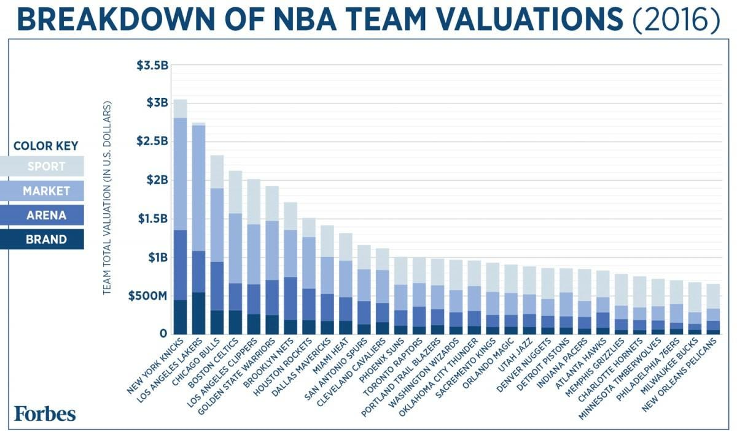
Image 1. NBA teams’ value (Taken from “Here's How Every NBA Team Makes Its Money, Visualized” in Forbes)
Of course there are other prestigious and popular leagues around the world like the Euroleague, the Basketball Champions League and the Chinese Basketball Association. All these associations are constantly finding new ways to implement and utilize AI tools in order to increase their competitiveness and success.

Threat of New Entrants
A significant investment is needed to start a new basketball club or league. This investment covers a range of costs, including player salaries, venue construction, marketing efforts, and administrative expenditures. One recent example of how new investors and companies can enter the basketball scene is Mat Ishbia's acquisition of the Phoenix Suns for a record 4 billion dollars.
New entrants in professional basketball need to invest heavily in AI-driven data and fan interaction tools to gain a competitive edge. Barlow & Sriskandarajah (2019) note that proper governance structures are crucial for fair competition among teams. League authorities should strictly oversee AI integration, potentially reducing the threat of new entrants.

Supplier Power
Top-tier players in the professional basketball industry wield significant negotiating power, using their skills and market value to secure significant salaries and endorsements. Media providers, like streaming services and broadcast networks, significantly influence basketball teams' revenue streams by managing game accessibility and distribution through media rights negotiations.
As already discussed, AI companies have become integral suppliers in the basketball industry, offering top-tier systems for player performance analysis, game strategy optimization, and fan engagement. Peterson (2024) emphasizes that as technology advances, these systems require continuous updates and maintenance, and the increasing demand for AI-driven applications can create a competitive disadvantage for smaller teams with limited budgets. This increases the power and influence of AI technology suppliers in the industry.

Customer Power
The professional basketball industry relies heavily on fans as primary customers, driving ticket sales, merchandising purchases, and viewership, which significantly impacts teams' and leagues' revenue streams. Teams aim to maintain fan interest and satisfaction while justifying ticket and merchandise prices.
As discussed before, AI systems are being used to optimize game strategies and player performance so that teams are more successful and their fans are satisfied. Moreover, teams are using AI-powered assistants and virtual reality systems to enhance customer experience and interests.

Threat of Substitutes
The main substitute products of the basketball industry refer to other professional or amateur sports leagues like college basketball, soccer, American football and tennis, which all compete for fan viewership and participation.
Yu-Ching Lo et al. (2023) note that AI technology is rapidly transforming sports analysis, with major events like basketball, baseball, and football adopting it as a standard practice. Shapiro & Velte (2023), who conduct research in the professional American football league (NFL) explain how teams can improve performance and outcomes by customizing their plans based on individual player profiles and team dynamics thanks to AI-driven insights. This presents a challenge for the basketball industry, which must continue investing and integrating AI solutions to stay competitive.

Future trends of the IS in the industry

Constant AI improvement
Garvey (2022) notes that the integration of AI in professional basketball is expected to lead to higher levels of athletic achievement and performance, ultimately influencing the competitive environment of the sport.
As Barlow & Sriskandarajah (2019) mention, AI programs contain huge amounts of performance data coupled with inputs from coaches and sports scientists. The data’s accuracy will be continuously updated along with advancements in specific tactics and strategies and will ultimately be used by sports scientists, coaches, and players for continuous performance enhancement.

Basketball 2030
Khanna (2023) suggests that with the worldwide AI sports industry expected to reach $19.2 billion by 2030, it is evident that AI has the power to change how players compete, how spectators interact, and even how games are evaluated.

The number of cameras on the field will only rise as more data is gathered. This information can be used enable more precise officiating and eliminate human errors. Artificial intelligence will eventually develop to make refereeing decisions as a result of this technological revolution, leading to the redundancy of human referees.

Ultimately by year 2030, there will be AI-driven systems providing coaches with real-time insights during games, virtual reality platforms with personalized experiences for fans and considerably advanced AI systems for injury prevention and training.

Conclusion

Key findings
In conclusion, the introduction of artificial intelligence into the professional basketball industry offers both opportunities and obstacles while altering the competitive landscape of the industry. AI technologies can significantly improve coaching and training techniques, player performance, and fan engagement increasing teams’ overall competitiveness. Nonetheless, worries about data privacy, overreliance on AI, and the possible replacement of human roles pinpoint to the necessity of careful implementation and moral execution. The future of the industry contains increased involvement of AI companies, more sophisticated AI systems and overall higher performance and competition levels in the industry.

Personal View
This study offers useful insights for stakeholders in the business, including team executives, coaches, players, and technology developers, by examining the opportunities and obstacles of AI integration. I believe that the results of this research provide a starting point for more in-depth investigation into particular areas of influence of AI within the professional basketball market.
In my opinion, the future of the sport, especially in terms of coaching, officiating and statistical analysis, will be significantly influenced by AI advancements and that the current landscape is just the beginning. I am really eager to witness and explore the innovations in viewership and gameplay that AI is going to offer in the next couple of years. However, I cannot hide my concerns regarding the ethical use of the technology and the implementation of effective regulations so that the sport remains competitive and, most importantly, keeps the human aspect that has made it one of the most popular sports in the world.

References
Barlow, A., & Sriskandarajah, S. (2019). Artificial Intelligence - Application to the Sports Industry. 10 Minutes on Sport.
Bishop, E. (2023, March 21). 5 ways NBA teams use analytics to gain a competitive edge. Sportskeeda. https://www.sportskeeda.com/basketball/5-ways-nba-teams-use-analytics-gain-competitive-edge
Bu, X. (2023). Exploration of Intelligent Coaching Systems: The Application of Artificial Intelligence in Basketball Training. Saudi Journal of Humanities and Social Sciences, 8(09), 290–295. https://doi.org/10.36348/SJHSS.2023.V08I09.007
Cain, D. (2023, June 19). AI and the Sports Industry. LinkedIn. https://www.linkedin.com/pulse/game-has-changed-ais-emergent-role-sports-industry-david-cain/
Finlay, D. (2023, October 10). The AI Revolution: Transforming the Future of Basketball. LinkedIn. https://www.linkedin.com/pulse/ai-revolution-transforming-future-basketball-david-finlay/
Garvey, R. (2022, December 22). Artificial intelligence is the new competitive edge in sports | Fortune. Fortune. https://fortune.com/2022/12/22/artificial-intelligence-is-the-new-competitive-edge-in-sports/
Khanna, A. (2023). Can AI Score Big In The Future Of Sports? Five Key Trends Shaping The Industry. Forbes Technology Council. https://www.forbes.com/sites/forbestechcouncil/2023/09/27/can-ai-score-big-in-the-future-of-sports-five-key-trends-shaping-the-industry/
Lau, D. (2017, May 20). How Artificial Intelligence is Changing the NBA. Medium. https://medium.com/@dominiclau/how-artificial-intelligence-is-changing-the-nba-47e2e33acc3d
Ozanian, M., & Teitelbaum, J. (2023). NBA Valuations 2023. Forbes. https://www.forbes.com/lists/nba-valuations/
Peterson, J. (2024, February 7). Artificial Intelligence in Sports Problem or an Opportunity? WittySparks. https://wittysparks.com/artificial-intelligence-in-sport-industry/
Pu, Q. (2021). The Effects of Artificial Intelligence on Competitive Sports. School of Professional Studies. https://commons.clarku.edu/sps_masters_papers/86
Shapiro, J., & Velte, T. (2023, June 16). Will AI Replace the Front Office in Pro Sports? Harvard Business Review. https://hbr.org/2023/06/will-ai-replace-the-front-office-in-pro-sports
Wei, W., Wei, J., Peng, J., & Liu, Z. (2020). Application of Artificial Intelligence Technology in Basketball Games. IOP Conference Series: Materials Science and Engineering, 750(1), 012093. https://doi.org/10.1088/1757-899X/750/1/012093
Yu-Ching Lo, Kuo-Wei Lin, & Xiao-Qing Wu. (2023). The Application of Big Data and Artificial Intelligence in Sports Industry. The International Journal of Business & Management. https://doi.org/10.24940/THEIJBM/2023/V11/I2/BM2302-001

